Vincent Tuberion – 10/28/21

Using the Binary Search Algorithm and trace table examples at the end of this document, complete the trace tables below for the Color Array. Upload this document to github and submit the link to your repository to the dropbox.

1st search: violet

|  |  |  |  |
| --- | --- | --- | --- |
| **First** | **Last** | **Middle** | **Comparison** |
| 0 | 10 | 5 | violet > indigo |
| 6 | 10 | 8 | violet > red |
| 9 | 10 | 10 | violet < yellow |
| 9 | 9 | 9 | violet == violet |
|  |  |  | return: True |

2nd search: green

|  |  |  |  |
| --- | --- | --- | --- |
| **First** | **Last** | **Middle** | **Comparison** |
| 0 | 10 | 5 | green < indigo |
| 0 | 4 | 2 | green > chartreuse |
| 3 | 4 | 4 | green = green |
|  |  |  | return: True |
|  |  |  |  |

3rd search: yellow

|  |  |  |  |
| --- | --- | --- | --- |
| **First** | **Last** | **Middle** | **Comparison** |
| 0 | 10 | 5 | yellow > indigo |
| 6 | 10 | 8 | yellow > red |
| 9 | 10 | 10 | yellow = yellow |
|  |  |  | return: True |
|  |  |  |  |

**Color array**:

|  |  |
| --- | --- |
| aqua | [0] |
| brown | [1] |
| chartreuse | [2] |
| dark brown | [3] |
| green | [4] |
| indigo | [5] |
| lavender | [6] |
| magenta | [7] |
| red | [8] |
| violet | [9] |
| yellow | [10] |

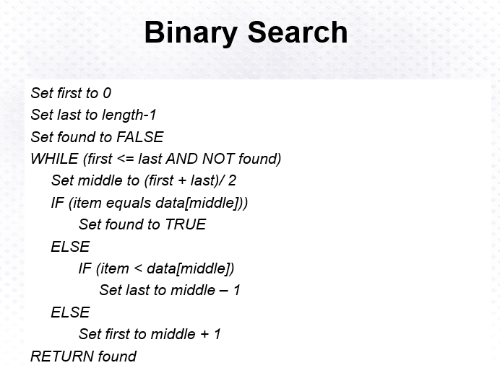

Above: Binary Search Algorithm

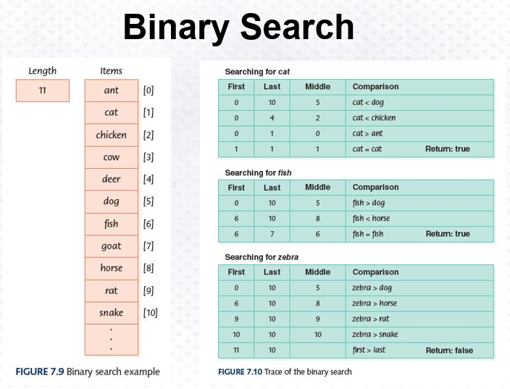

|  |
| --- |
| # Binary Search Code by Vincent Tuberion using provided Pseudocode  data = ["aqua", "brown", "chartreuse", "dark brown", "green", "indigo", "lavender", "magenta", "red", "violet", "yellow"] first = 0 last = len(data) - 1 item = input() found = False while first <= last and not found:    middle = round((first + last) / 2)    print("New Comparison: " + str(first) + ", " + str(last) + ", " + str(middle) + ", " + data[middle])    if item == data[middle]:        found = True    elif item < data[middle]:        last = middle - 1    else:        first = middle + 1 print(found) |